MAIN PROJECT SYNOPSIS

Smart Traffic Prediction and

Intelligent Traffic Management System

Submitted by :- Nedha Saleem
Programme :- Data Science with Python
March 2026 – August 2026
1. Introduction
Traffic congestion is a major challenge in urban and metropolitan areas, resulting in increased travel time, fuel consumption, environmental pollution, population growth, limited road capacity, accidents, variations in travel patterns and reduced transportation efficiency. Traffic conditions are influenced by several factors including time of day, day of the week, unpredictable weather conditions, holidays, and historical traffic patterns.
Traditional traffic management approaches may not adequately capture the complex and dynamic relationships between these factors. Artificial Intelligence provides an opportunity to develop predictive systems capable of learning from historical traffic data and generating useful insights.
Recent developments in Artificial Intelligence provide opportunities to build intelligent traffic management systems capable of learning from historical data and identifying complex patterns. Machine Learning can be used to predict traffic volume based on factors such as time, weather, holidays, and previous traffic conditions. Deep Learning models, particularly Long Short-Term Memory (LSTM) networks, can further capture temporal dependencies in traffic data. Generative AI can complement these predictive models by providing natural-language explanations, generating traffic reports, and enabling users to interact with the system through a conversational interface.
The proposed project aims to develop an integrated Smart Traffic Prediction and Intelligent Traffic Management System combining Machine Learning, Deep Learning, and Generative AI.

2. Problem Statement
Existing traffic prediction systems may provide numerical predictions but often lack an intuitive mechanism for users to understand the reasons behind those predictions. Additionally, traditional prediction models may struggle to capture complex temporal patterns in traffic data.
Therefore, there is a need for an intelligent system that can:
- Predict future traffic volume accurately.
- Identify temporal traffic patterns.
- Compare traditional ML and DL approaches.
- Explain predictions in an understandable manner.
- Provide traffic-related information through natural-language interaction.
- Present predictions and insights through an interactive interface.
The proposed system addresses these requirements by integrating ML-based prediction, DL-based time-series forecasting, and GenAI-powered assistance.

3. Objectives
The major objectives of the project are:
- To collect and preprocess historical traffic data.
- To perform exploratory data analysis and identify important traffic patterns.
- To develop Machine Learning models for traffic volume prediction.
- To develop an LSTM-based Deep Learning model for time-series traffic prediction.
- To compare the performance of ML and DL models using appropriate evaluation metrics.
- To develop a Generative AI-based Intelligent Traffic Assistant.
- To provide natural-language explanations for traffic predictions.
- To implement a Retrieval-Augmented Generation (RAG) system using traffic-related knowledge sources.
- To develop an interactive dashboard for displaying traffic predictions and insights.
- To provide an integrated platform for intelligent traffic analysis and decision support.

4. Dataset / Knowledge Source
The primary dataset will be the Metro Interstate Traffic Volume Dataset from the UCI Machine Learning Repository.
The dataset contains 48,204 hourly observations collected between 2012 and 2018 from westbound I-94 near Minneapolis–St. Paul. It contains traffic volume along with weather and holiday information.
The primary target variable will be:
Traffic Volume (vehicles/hour)
Input variables will include:
- Date and time
- Hour
- Day of week
- Month
- Holiday information
- Temperature
- Rain
- Snow
- Cloud coverage
- Weather conditions
- Historical traffic volume
The data will be divided chronologically into training, validation, and testing sets to avoid leakage from future observations.

5. Proposed System
The proposed system consists of three major AI components:
A. Machine Learning Methodology
The ML module will predict traffic volume using historical traffic and contextual features.
The target variable will be traffic volume.
Several regression algorithms will be investigated, including:
- Linear Regression
- Random Forest Regressor
- XGBoost Regressor
- LightGBM Regressor
In addition to these supervised ML models, ARIMA (AutoRegressive Integrated Moving Average) will be implemented as a classical time-series forecasting model. ARIMA will utilize the temporal structure of historical traffic observations and provide a traditional forecasting baseline for comparison with the ML and Deep Learning approaches.
The models will be compared using:
- Mean Absolute Error (MAE)
- Mean Squared Error (MSE)
- Root Mean Squared Error (RMSE)
- R² Score
The best-performing model will be selected for the prediction component.
B. Deep Learning Methodology
Traffic data is inherently sequential because traffic conditions at a particular time are influenced by previous traffic conditions. Therefore, a Deep Learning model capable of learning temporal dependencies will be developed.
The primary architecture selected for this project is Long Short-Term Memory (LSTM).
The LSTM model will use sequences of historical traffic observations to predict future traffic volume.
For example:
Previous 24 hours
↓
LSTM
↓
Next-hour traffic volume
The LSTM model will be trained using TensorFlow/Keras.
Its performance will be compared with the selected ML models to determine whether the DL approach provides improved prediction performance for sequential traffic data.

C. Generative AI Methodology
The Generative AI component will function as an Intelligent Traffic Assistant.
Instead of simply displaying numerical predictions, the system will translate predictions into understandable natural-language insights.
For example:
Prediction:
Expected traffic volume: 5,800 vehicles/hour
The system may generate:
"High traffic is expected during the evening period. Historical traffic patterns indicate that this time corresponds to a peak commuting period."
The GenAI module will provide:
- Prediction explanations
- Traffic summaries
- Natural-language queries
- Daily/weekly traffic reports
- Traffic-management information
- User interaction through a chatbot

6. Retrieval-Augmented Generation
To improve the reliability of the Generative AI component, a Retrieval-Augmented Generation (RAG) approach will be implemented.
Relevant knowledge sources may include:
- Traffic management documents
- Road safety documents
- Intelligent transportation system documents
- Traffic-related FAQs
- Government transportation guidelines
- Project documentation
The system will use Ollama with Llama 3.2 as the local Large Language Model and LangChain for integrating the retrieval and generation components.
Sentence-transformer embeddings will be used to represent documents in vector space, while ChromaDB will be used as the vector database.

7. System Architecture Diagram

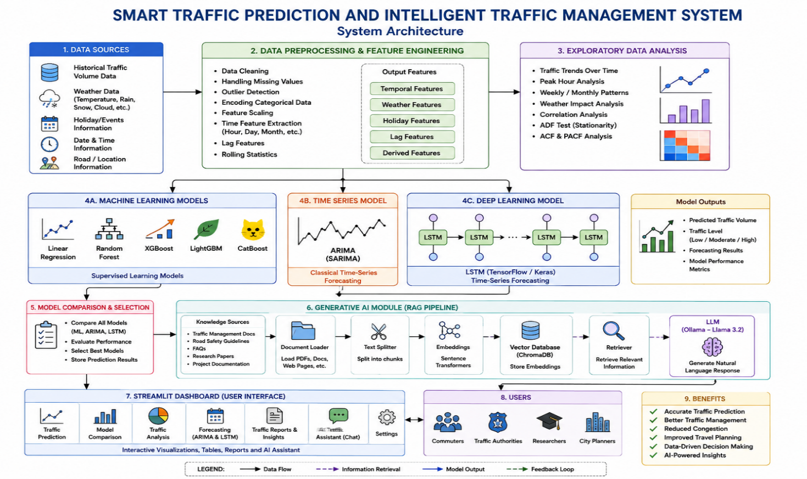

8. Technology Stack
Category | Technology
Programming Language | Python
Data Processing | Pandas, NumPy
Data Analysis | SciPy, Scikit-learn
Visualization | Matplotlib, Seaborn, Plotly
Machine Learning | Scikit-learn, XGBoost, LightGBM
ML Algorithms | Linear Regression, Random Forest, XGBoost, LightGBM
Time-Series Analysis | Statsmodels
Time-Series Techniques | ADF, ACF, PACF, ARIMA
Deep Learning | TensorFlow, Keras
DL Architecture | LSTM
LLM | Llama 3.2
LLM Runtime | Ollama
GenAI Framework | LangChain
Embeddings | Sentence Transformers
Vector Database | ChromaDB
RAG | LangChain + ChromaDB
Development | Jupyter Notebook, VS Code
Version Control | Git, GitHub

9. Expected Outcomes
The proposed system is expected to:
- Develop an ML model capable of predicting traffic volume.
- Develop an LSTM-based model for sequential traffic forecasting.
- Compare the performance of traditional ML and Deep Learning approaches.
- Identify important factors influencing traffic conditions.
- Provide understandable explanations for model predictions.
- Develop a RAG-based traffic information assistant.
- Enable users to interact with traffic information using natural language.
- Provide interactive visualizations of historical and predicted traffic.
- Generate automated traffic reports and insights.
- Demonstrate an integrated application combining Machine Learning, Deep Learning, and Generative AI.

10. Future Scope
The proposed system can be extended in several ways:
- Integration with real-time traffic APIs.
- Incorporation of live weather data.
- Integration of CCTV/video feeds.
- Use of YOLO for vehicle detection and counting.
- Use of Transformer-based time-series models.
- Real-time traffic congestion alerts.
- Route optimization.
- Integration with smart-city infrastructure.
- Mobile application development.
- Deployment on cloud platforms.

11. Conclusion
The proposed Smart Traffic Prediction and Intelligent Traffic Management System aims to provide an AI-driven approach to traffic analysis and prediction. By combining Machine Learning, Deep Learning, and Generative AI, the system will not only predict future traffic conditions but also provide meaningful explanations and natural-language interaction.
Machine Learning algorithms will be used to establish reliable traffic prediction models, while an LSTM-based Deep Learning model will capture temporal dependencies in traffic patterns. The Generative AI component, supported by Retrieval-Augmented Generation, will provide an intelligent interface through which users can understand predictions, obtain traffic-related information, and generate reports.
The final system will be implemented as an interactive dashboard, providing a practical demonstration of how modern AI technologies can be integrated to address real-world transportation challenges.

